Effect of Salinity on some morphological and physiological characters of Oat (Avena sativa L.) plants
Sargul A. Khudhur ¹ ; Younis H. Mustafa ² and Aroul M. Anwar²

Kurdistan Region- Iraq/ Koya University/Faculty of Science and Health/ Department of Biology
E-mail: sargul.ahmed@koyauniversity.org

Abstract
The experiment was conducted in a private field at Biology department /Faculty of Science and Health / Koya University / Kurdistan region, located at 44º E, 33 º4N and 570 m of altitude above sea level. A factorial experiment with randomized complete block design (R.C.B.D.) with three replications was conducted to study the combination effect of two Oat species (Possum T1 and Icarda tall T₂₎ and salinity (NaCl) with four concentrations 0, 0.5, 1 and 2% (C₀, C_{1,} C_{2,} and C₃), tap water was used as a control. When Avena sativa plant was exposed to various concentrations of salinity, and they were found to have NaCl and accumulation in plants. NaCl stress inhibited plant growth and had a significant effect on the plant height, number of leaves, diameter of plant, leaf area, root length and flag leaf area, length of spike and shoot dry matter. Shows have significant effects, but decreasing on some vegetative growth, leaves chemical content and some stomata characteristics as compared with control. Overall, these results showed that plant growth of Icarda tall species is a potentially useful candidate gene for salinity.
keywords: Avena sativa, Species, Salinity, Morphological response.
Introduction
Oat (Avena sativa L.) is an annual grass and belong to the natural order Poaceae family (Chatuevedi et al, 2011).It is an important and traditional agricultural cereal crop produced in various regions of Europe and North America. It is the third leading crops produced the United States (after wheat and corn) and the fourth most important crop worldwide (Brindzova, 2008 and Lindlöf et al, 2005; Ben Saad et al, 2014 and Landizinsky, 2012).Oat is one of the most economically and ecologically families in the world. They are the most widely grown plants considered healthy food being commercially nutritious as well. Also, it is used in external preparations to treat eczema and dry skin. Today, it was used for hay, pasture, green manure, or as a cover crop, which enhances soil life, suppresses weeds, provides erosion control and increases organic component (Chatuevedi et al, 2011).

Salt stress is one of the most serious, limiting factors for crop growth and production in the arid regions about 23% of the world’s cultivated lands are saline and 37% is sodic (Khan and Duke, 2001).Soils can be saline, due to geo-historical processes. Soil salinity in agriculture soils refers to the presence of high concentrations of soluble salts in the soil moisture in the root zone. These concentrations of soluble salts through their high osmotic pressures affect plant growth by restricting the uptake of water by the roots (Tester and Devenport, 2003). Salinity stress by excess salts in the soil or irrigation water is known to affect various growth processes including photosynthesis, ion regulation, and water relations. Thus, a wide range of physiological and biochemical processes is necessary to re-establish cellular homeostasis (Zhifang and Loescher, 2003; Kumar et al , 2014 and Ben Saad et al, 2014).

Nutrient disturbances under salinity reduce plant growth by affecting the availability, transport, and partitioning of nutrients. However, salinity can differently affect the mineral nutrition of plants. Salinity may cause nutrient deficiencies or imbalances, due to the competition of Na⁺ and Cl– with nutrients such as K⁺, Ca²⁺ and NO^{3–.} Under saline conditions, a reduced plant growth due to specific ion toxicities (e.g. Na⁺ and Cl–) and ionic imbalances acting on biophysical and metabolic components of plant growth occurs (Grattan and Grieves , 1999).Increased NaCl concentration has been reported to induce increases in Na and Cl as well as decreases in N, P, Ca, K and Mg level in fennel (Abd El-Wahab, 2006; Ashraf and Orooj, 2006; Tabatabaie & Nazari, 2007 and Baghalian et al., 2008).

The purpose of this experiment was to evaluate the effects of different species of Oat and irrigation water with different concentration of salt on the vegetative growth and chemical characteristics and some stomata characteristics of A.sativa plant.

Material and Methods
A.Plant materials and treatment: The experiment was conducted in 2015- 2016 of the open field of Biology department in Koya district. Oat grains (Avena sativa) were purchased from ICARDA organization, two species of the oat grains used POSSUM (T₁) and ICARDA Tall (T₂), in each type of oat 180 seeds were taken, these seeds were divided into the 12 plastic pots each plastic pot contained 15 seeds and filled with loamy soil a growth medium. The loamy soil was taken from research center from Koya city. Oat grains (Possum and Icarda tall) were sown on January 10, 2016.

B.Evaluation of Avena sativa plants grown with salt stress: A factorial experiment with randomized complete block design (R.C.B.D.) with three replications was applied to study the combination of two species of Oat (T₁ and T₂) and salinity (NaCl) with four concentrations of (C₀, C_{1,} C_{2,} and C₃). The irrigation program, used for watering the plants was a solution containing 0, 5, 10 and 20g of NaCl dissolved in 1000 ml tap water to obtain concentrations (0, 0.5, 1and 2 %), tap water was used as a control. The effects of salt treatments on Avena sativa plants under natural conditions. Groups of 360 seeds were germinated after 30 days in 24 plastic pots, then plants were irrigated with sodium chloride (NaCl) nutrient solution every three days (250 ml per day). Oat irrigation program in (March to May 2016) under effect salt stress. Sixty days later, the characteristics were studied on vegetative growth, the chemical content of leaves and some stomata characteristics of Avena sativa plant.

C.Meteorological data:
Maximum and Minimum temperature, the relative humidity and the amount of Rain fall in the open field during the planting season are shown in the table (1), as recorded by Agro-Meteorological Station in Koya city.

Table 1: Maximum and minimum temperature, the relative humidity and the amount of rain fall during the growing season (2015-2016).
Rainfall  (mm) | Relative Humidity% |  | Air Temp. Cº |  | Month  (2016)
 | Minimum | Maximum | Minimum | Maximum
100 | 69.9 | 77.8 | 5.03 | 9.8 | January
49 | 59.3 | 68.1 | 9.4 | 15.8 | February
170 | 60.1 | 68.8 | 10.7 | 18.1 | March
79 | 71.2 | 75.0 | 15.5 | 20.1 | April

On (May 1, 2016) the following characteristics were studied:
A.Vegetative growth included:
- Plant height (cm): It was measured from the point of stem attachment with soil to the apical point of the main shoot by using metric tapeline.
- Number of leaves/plant: Total numbers of leaves were counted, including those leaves that can be seen by naked eyes, then taken and measured by hands.
- A Number of tillers/plant: Total numbers of tillers were counted including branches that can be seen by naked eyes.
- Root length (cm): It was measured from the point of stem attachment with soil to the apical point of the main root by using metric tapeline after washing and rinsing in tap water.
- Stem diameter (mm/plant): Diameter of main branches was measured by Vernier micrometer.
- Leaf area (cm²/plant): Ten leaves were selected randomly from fifteen plants, after measured comprise the leaf length(L) from the lamina tip to the connected place petiole to a lamina and width(W) from tip to tip at the widest of the lamina, by a ruler, leaf area calculated by the formula described by Thomas,1975:
La (cm²) = Length * Width * 0.95
- Flag leaf area (cm²/plant): Ten leaves were selected randomly from plants, after a measured comprise leaf length(L) from a lamina tip to the connected place petiole to the lamina and width(W) from tip to tip at the widest of a lamina, by that the ruler, leaf area calculated by the formula described by Thomas,1975:
La (cm²) = Length * Width * 0.95
- The length of a spike (cm): It was measured from the tip of the stem attached with a spike to the apical point of main a spike by using the ruler.
- Number of seed spike/plant: Total number of seeds the spike was counted, including that a spike that can be seen by naked eyes.
- Shoots and roots dry matter (%): The dry weight of root and shoot were measured after keeping the fresh plant samples in hot air oven at 70 C for 48 hours until the weight fixed, shoot and root dry matter % were calculated by using the following formula described by Al-Sahaf 1989:

Shoot (or Root) dry weight
Shoot (or Root) dry matter (%) = x 100
Shoot (or Root) fresh weight

B. Chlorophyll content (mg/100g fresh weight):

The amount of chlorophyll a, b, and total chlorophyll were estimated according to the method of (Tang, 2004). Leaf material was collected and 0.25g of fresh leaves of each experimental unit was taken, then mixed with 10 ml 80% acetone, this extract was placed in a 25ml glass vial (dark bottle). The glass vials were sealed with par film to prevent evaporation, to avoid photo oxidation of pigments, and then 1 ml of extract was added to 9 ml of acetone. Chlorophyll a, chlorophyll b, and total chlorophyll were measured by a spectrophotometer (PD-303) at 663 nm and 645 nm wavelengths, as follows:

Chlorophyll a (mg/liter) = (9.784 x OD at 663 nm) - (0.99 x OD at 645 nm)
Chlorophyll b (mg/liter) = (21.426 x OD at 645 nm) - (4.65 x OD at 663 nm)
Total chlorophyll (mg/liter) = (5.134 x OD at 663 nm) + (20.436 x OD at 645 nm)
Carotenoid (mg/liter) = (4.695 x 440 nm) + 0.268 (Chlorophyll a + Chlorophyll b)

The following formula used for transferring chlorophyll content from mg/liter to mg/100 g fresh weight:
mg / l 100 g
mg chlorophyll /100 g fresh weight = x
- ml g sample

C.Number, length, and width of stomata on upper and lower leaf surface:
Three leaves were selected from different plants carefully from each experimental unit and kept in polythene bags during May 10, 2016, and brought to the laboratory. The leaf epidermal peel slides were made by the methods of lasting impressions. In this method, at least one square centimeter on leaf surface was painted by a thick patch of clear nail polish. The nail polish to be allowed to dry completely, then a piece of clear cellophane tape to the dried nail polish patch was placed via carton sealing tape. Gently, the nail polish patch peeled out by pulling a corner of the tape and finger nail polish along with the leaf peel, which was taped on slides and labelled as an adaxial and an abaxial surface. Leaf was examined under at least 100x magnifications by light microscope. Numbers of stomata were counted per square millimeter area. Length and width of stomata guard cells of a leaf were measured in μm (micron) with an ocular micrometer under high power magnifications with the help of Stage - Ocular micrometer (Rai and Mishra, 2013).
Statistical analysis: Comparisons between means were made by using Duncan’s Multiple Range test at 5% level (Reza, 2006). The statistical analysis was carried out by using the SAS Program (2000).
Results and Discussions

Effect of salinity concentration and two Oat species on vegetative growth, leaves chemical content and some stomata characteristics
Vegetative growth characteristics:
Table (2) shows the response has significantly affected two Oat species to vegetative growth, including plant height, number of tillers, leaf area and root length from treatment which recorded the highest value in Icarda tall species (80.96 cm, 5.78, 43. 02 cm² and 15.78 cm) for the parameters respectively, while the lowest values were recorded in Possum plant (51.55 cm, 4.87, 37.64 cm² and 12.67cm) respectively, but decreasing in number of leaves and diameter of plants. There were no-significant differences between the different species of Oat and salinity concentration on their parameters. That increasing salinity concentration in irrigation water caused decreases in plant vegetative growth compared to control treatment. Irrigation water with salinity concentration and their interactions with a different species of Oat had the significant effect on the plant height, number of leaves, stem diameter, leaf area and root length, but decreasing on some vegetative growth as compared with control.

Table 2: Effect of salinity of irrigation water and two Oat species and their interactions on vegetative growth
Treatment | Plant height  (cm) | Number of  leaves  /plant | Number of  tillers/plant | Stem diameter  mm/plant | Leaf area (cm)² | Root length  (cm)
Species of Oat
T1 | 51.55 b | 34.59 a | 4.87 a | 4.52 a | 37.64 b | 12.67 b
T2 | 80.96 a | 28.98 a | 5.78 a | 4.09 b | 43. 02 a | 15.78 a
Salinity Concentration (%)
Tap water (C0) | 68.00 a | 37.10 a | 4.77 a | 4.42 a | 42.77 a | 12.50 a
0.5 (C1) | 68.50 a | 33.75 a | 4.83 a | 4.20 a | 40.70 a | 14.01 a
1 (C2) | 69.78 a | 28.51 a | 5.88 a | 4.56 a | 40.81 a | 15.76 a
2 (C3) | 64.23 a | 28.51 a | 5.78 a | 4.00 a | 38.75 a | 14.56 a
The interactions between two Oat species & NaCl Con.
T1C0 | 42.70 c | 45.40 a | 6.70 a | 6. 00 a | 46.80 a | 9.00 b
T1C1 | 52.23 bc | 37.63 ab | 4.66 a | 4.30 b | 36.33 ab | 11.23 ab
T1C2 | 55.46 b | 28.20 bc | 4.66 a | 4.76 b | 39.23 ab | 14.86 a
T1C3 | 49.90 bc | 34.33 abc | 4.66 a | 4.00 b | 34.30 b | 13.13 ab
T2C0 | 76.43 a | 34.33 abc | 4.13 a | 3.90 b | 41.43 ab | 13.66 ab
T2C1 | 84.76 a | 29.86 bc | 5.00 a | 4.10 b | 45.06 ab | 16.80 a
T2C2 | 84.10 a | 29.87 bc | 7.10 a | 4.36 b | 42.40 ab | 16.66 a
T2C3 | 78.56 a | 22.90 c | 6.900 a | 4.00 b | 43.20 ab | 16.00 a

*Means followed by the same letters within columns are not significantly different at p≤ 0.05 according to the Duncan test.
Icarda tall species was superior to possum one in stimulating the morphological growth. Tables (2) showed that in Icarda tall species all growth parameters significantly increased compared to the possum species, this effect may be attributed to the physical properties of the plants. The growth of plant decreased with increasing the salinity concentration because salinity can also affect plant growth (plant physiological, morphological, and biochemical processes growth and water), because the high concentration of salts in the soil solution interferes with balanced absorption of essential nutritional ions by plants (Tester and Devenport, 2003; Kumar et al, 2014; Ben Saad et al, 2014 and Chauhan et al, 2016).The results agreed partially with (Hirich et al, 2014). Who confirmed that irrigation water with salinity decreased vegetative growth in Chickpea (Cicer arietinum L).

Table 3: Effect of salinity of irrigation water and two Oat species and their interactions on the growth.
Treatment | Flag  leafarea (cm)² | Length of spike  (cm) | Number of  Seed spike /plant
Species of Oat
T1 | 33.48 a | 13.87 b | 25.19 a
T2 | 24.77 b | 16.76 a | 23.20 a
Salinity Concentration (%)
Tap water (C0) | 30.88 a | 15.78 a | 24.71 a
0.5 (C1) | 27.67 a | 15.58 a | 24.62 a
1 (C2) | 29.27 a | 15.83 a | 25.05 a
2 (C3) | 28.68 a | 14.05 a | 22.40 a
The interactions between two Oat species & NaCl Con.
T1C0 | 36.77 a | 18.33 a | 28.53 a
T1C1 | 30.53 abc | 13.37 b | 24.23 a
T1C2 | 32.43 abc | 12.43 b | 26.10 a
T1C3 | 34.20 ab | 11.33 b | 21.90 a
T2C0 | 25.00 bc | 13.23 b | 20.90 a
T2C1 | 24.80 bc | 17.80 a | 25.00 a
T2C2 | 26.10 bc | 19. 23 a | 24.00 a
T2C3 | 23.17 c | 16.77 a | 22.90 a

*Means followed by the same letters within columns are not significantly different at p≤ 0.05 according to the Duncan test.

Results in table (3) showed that there were a significant difference between two Oat species and salt concentrations in their effect on the flag leaf area and length of the spike, this effect may be attributed to the physical properties of the plants. The results agreed partially with (Dhanapackiam and Muhammad Ilyas, 2010 and Iqbal, 2003) who confirmed that irrigation water with salinity decreased vegetative growth.

The results in table (4) showed significant differences between two Oat species in the shoot dry matter, the highest value was recorded in Icarda tall species, while the lowest value was recorded in possum species. Irrigation water with salinity had no significant effect on this parameter. The interaction between different species and irrigation water with salinity had a significant effect on the shoot dry matter, the highest value was obtained from Icarda tall species with concentration 2%, while the lowest value was obtained from Possum species.

Table 4: Effect of salinity of irrigation water and two Oat species on shoot & root dry matter of leave content.

Treatment | Shoot dry Matter (%) |  | Root dry Matter (%)
Species of Oat
T1 |  | 41.94 b |  | 45.94 a
T2 |  | 51. 85 a |  | 50.33 a
Salinity Concentration %
Tap water (C0) |  | 54.57 a |  | 39.80 a
0.5 (C1) |  | 42.48 a |  | 45.42 a
1 (C2) |  | 45.48 a |  | 47.10 a
2 (C3) |  | 49.26 a |  | 58.18 a
The interactions between two Oat species &NaCl Con.
T1C0 |  | 45.00 ab |  | 53.90 a
T1C1 |  | 37.63 b |  | 28.90 a
T1C2 |  | 45.03 ab |  | 55.90 a
T1C3 |  | 42.13 ab |  | 50.37 a
T2C0 |  | 57.76 a |  | 35.10 a
T2C1 |  | 47.33 ab |  | 61.93 a
T2C2 |  | 45.93 ab |  | 38.30 a
T2C3 |  | 56.40 ab |  | 66.00 a
*Means followed by the same letters within columns are not significantly different at p≤ 0.05 according to the Duncan test.

The saline growth medium caused many adverse effects on plant growth, which was due to the low external water potential (osmotic stress). Under salt stress, plants have to cope with stress imposed by low osmotic potential and with ion toxicity due to the accumulation of ion inside the plants. Fresh and dry weights were also decreased with increasing salinities in shoot and root dry matter. The results agreed partially with (Kumar et al, 2014 and Amira and Abdul, 2011).

Results in the table (5) showed that significant differences were found between two Oat species on chlorophyll content, while irrigation water with salinity (2%) had significant effect on the chlorophyll a, b and total chlorophyll as compared with control. The interaction between different species and salinity concentrations had significant effect on the chlorophyll a, b and total chlorophyll characteristic. The highest values (5.50, 4.63 and 10.06) were obtained from Icarda tall species and irrigation water with 2% salinity, while, the lowest values (3.10, 1.10 and 4.20) were obtained from Possum species with no salinity.

Table 5: Effect of salinity of irrigation water and two Oat species on leaf content of chlorophyll A, B, Total chlorophyll
and Total carotene.
Treatment | Chlorophyll a | Chlorophyll b | Total Chlorophyll | Total Carotenoids
 | Mg/100g fresh weight
Species of Oat
T1 | 4.13 a | 4.51 a | 8.63 a | 4.33 a
T2 | 4.35 a | 3.35 b | 7.69 a | 4.06 a
Salinity Concentration %
Tap water (C0) | 4.30 ab | 2.97 b | 7.27 b | 4.13 ab
0.5 (C1) | 3.68 b | 3.51 b | 7.21 b | 3.87 b
1 (C2) | 4.05 b | 3.83 ab | 7.86 ab | 4.05 ab
2 (C3) | 4.98 a | 4.88 a | 9.83 a | 4.73 a
The interactions between two Oat species & NaCl Con.
T1C0 | 3.10 d | 1.10 e | 4.20 d | 4.03 ab
T1C1 | 3.43 bcd | 3.93 abcd | 7.36 abcd | 3.80 ab
T1C2 | 4.83 ab | 5.60 a | 10.40 a | 4.87 a
T1C3 | 4.46 bcd | 5.13 ab | 9.60 ab | 4.63 a
T2C0 | 4.70 abc | 3.60 bcd | 8.30 ab | 4.23 ab
T2C1 | 3.93 bcd | 3.10 cd | 7.06 bcd | 3.93 ab
T2C2 | 3.26 cd | 2.06 de | 5.33 cd | 3.23 b
T2C3 | 5.50 a | 4.63 abc | 10.06 ab | 4.83 a

*Means followed by the same letters within columns are not significantly different at p≤ 0.05 according to the Duncan test.

The result showed that the salt treatment increased significantly chlorophyll a, b, total chlorophyll and total
carotenoids increased with increasing salinity concentration, the results agree with (Saida, et al, 2014 and
Amira and Abdul, 2011).

The results in the table (6) and figures (2 and 3) showed the stomata structure in Avena sativa plants where both adaxial and abaxial epidermis have stomata. The anatomical study showed that there were no significant differences between species on this parameter. Except for stomata length in lower (abaxial) surface there was significantly increases in Icarda tall species, it,s height value (7.08), while the lowest value was recorded in possum species (6.38). However, no significant effects were observed by irrigation water with a different concentration of salinity. The interaction between the different species of Oat and irrigation water with salinity had a significant effect on each of stomata number on the upper surface, stomata length, and width of upper surface respectively.

Table 6: Effect of salinity of irrigation water & two Oat species and their interactions on some stomata characteristics.
Treatment | Stomata Number /mm² |  | Stomata length (micron) |  | Stomata width (micron)
 | Upper leaf  surface | Lower  leaf  surface | Upper  leaf surface | Lower  leaf surface | Upper  leaf  surface | Lower  leaf  surface
Species of Oat
T1 | 190.50 a | 210.41 a | 6.71 a | 6.38 b | 4.39 a | 4.00 a
T2 | 185.61 a | 194.93 a | 6.73 a | 7.08 a | 4.49 a | 4.191 a
Salinity Concentration %
Tap water (C0) | 203.53 a | 233.13 a | 6.80 a | 7.07 a | 4.10 b | 4.07 a
0.5 (C1) | 179.30 a | 205.97 ab | 6.41 a | 6.63 a | 4.18 b | 4.20 a
1 (C2) | 179.85 a | 188.32 b | 6.77 a | 6.66 a | 4.66 a | 3.76 a
2 (C3) | 193.88 a | 190.85 b | 6.91 a | 6.78 a | 4.71 a | 4.36 a
The interactions between two Oat species & NaCl Con.
T1C0 | 237.50 a | 236.70 a | 7.10 a | 6.50 a | 4.10 c | 4.10 a
T1C1 | 179.17 b | 222.20 a | 6.70 ab | 6.33 a | 4.16 bc | 4.20 a
T1C2 | 182.23 ab | 199.70 a | 6.26 ab | 6.10 a | 4.43 abc | 3.70 a
T1C3 | 194.43 ab | 200.57 a | 7.03 ab | 6.66 a | 4.66 abc | 4.06 a
T2C0 | 192.20 ab | 231.93 a | 6.70 ab | 7.26 a | 4.10 c | 4.06 a
T2C1 | 179.17 b | 189.73 a | 6.13 b | 6.93 a | 4.20 bc | 4.20 a
T2C2 | 177.47 b | 176.93 a | 7.26 a | 7.23 a | 4.90 a | 3.83 a
T2C3 | 193.33 ab | 181.13 a | 6.80 ab | 6.90 a | 4.76 ab | 4.66 a

*Means followed by the same letters within columns are not significantly different at p≤ 0.05 according to the Duncan test.
Salt stress induces the synthesis of abscisic acid which closes stomata when transported to guard cells. As a result of the stomatal closure, photosynthesis declines and photo inhibition and oxidative stress occur. An immediate effect of osmotic stress on plant growth is its inhibition of cell expansion either directly or indirectly through abscisic acid (Jouyban, 2012).
Salt stress significantly reduced the growth of the two tall oat grass genotypes during the seedling stage. The stomatal inhibition of photosynthesis, caused by direct effects of NaCl on the photosynthetic apparatus independent of the stomatal closure, might be responsible for the reduction in photosynthetic rate. Stomata characteristics like the number, length, and width are affected by the genetic constitution, season, leaf position and leaf surface (upper or lower).These results partially agreed with (Zan,et al.,2011).

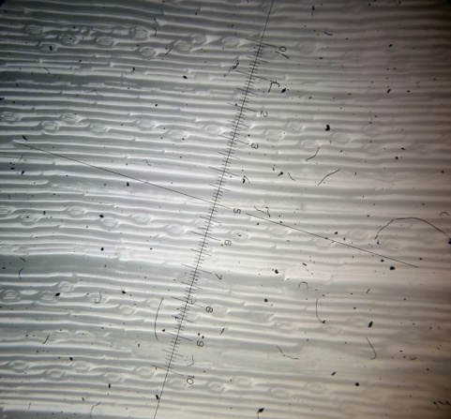 | 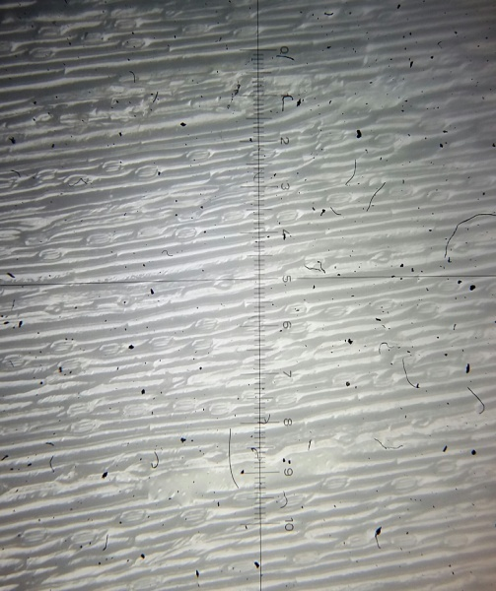 | 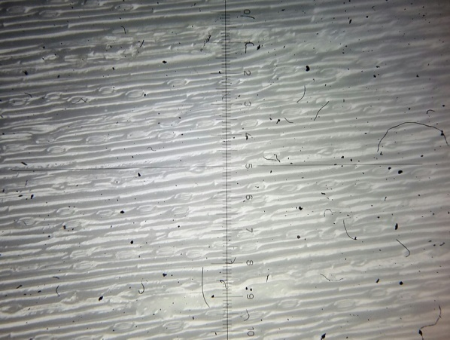 | 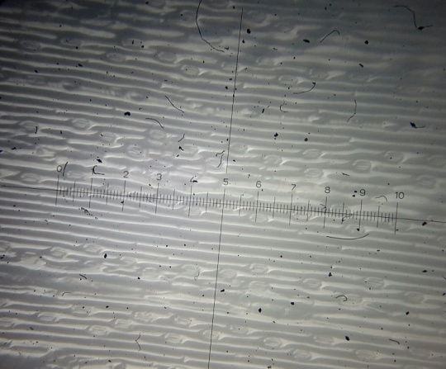  Stomata
T₁C₃U | T₁C₂U | T₁C₁ U | T₁C₀U
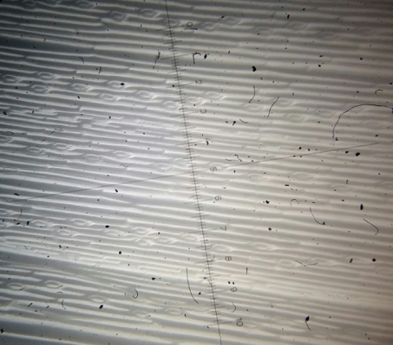 | 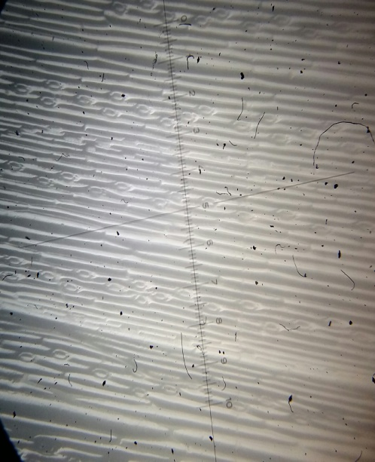 | 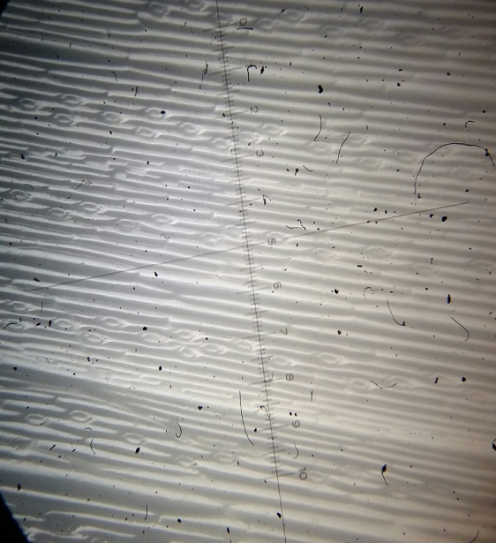 | 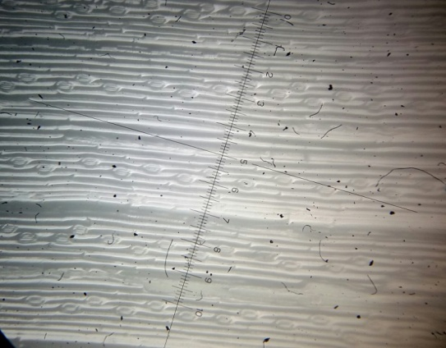
T₁C₃ L | T₁C₂ L | T₁C₁L | T₁C₀L
Figure 2: Upper (adaxial) and Lower (abaxial) Avena sativa leaves surfaces stomata 100X (T₁C₀ U& L) stomata in Possum plants and no irrigation water with salinity, (T₁C₁ U& L) stomata in Possum plants and irrigation water with salinity 0.5%, (T₁C₂U& L) stomata in Possum plants and irrigation water with salinity1%, (T₁C₃ U& L) stomata in Possum plants and irrigation water with salinity 2%.
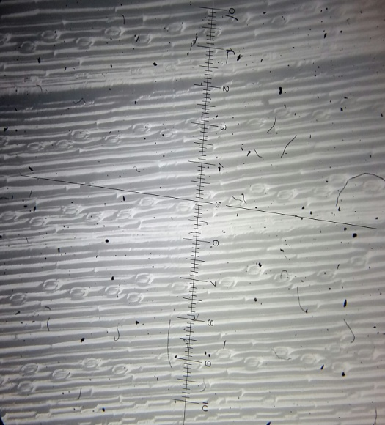 | 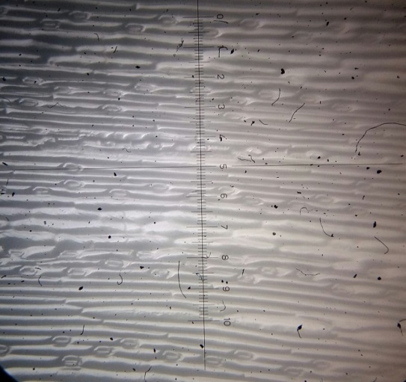 | 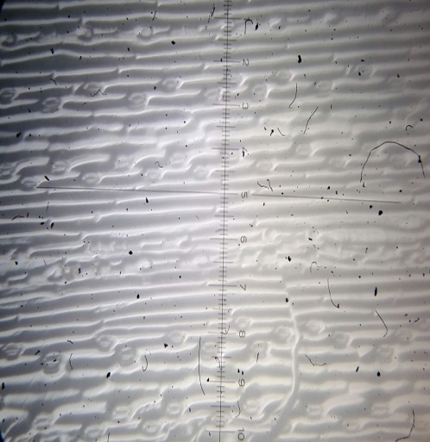 | 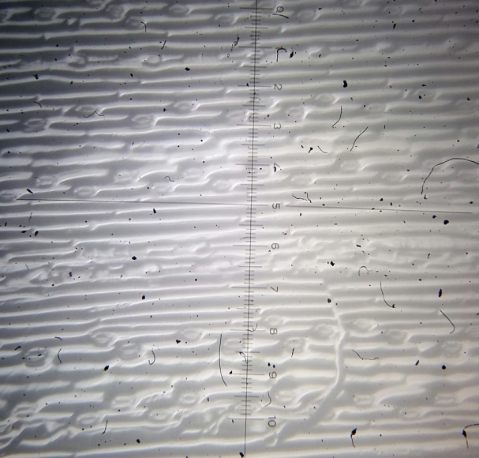
T₂C₃u | T₂C₂u | T₂C_{.1}u | T₂C₀u
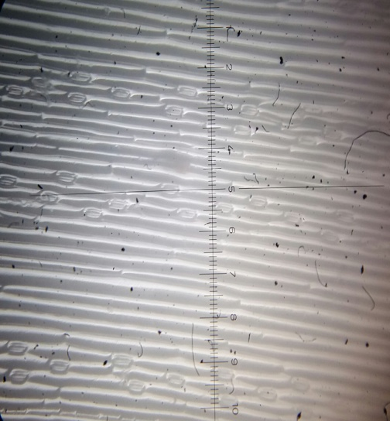 | 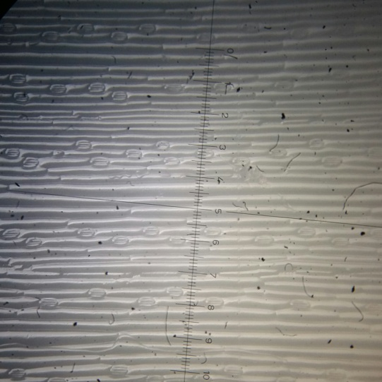 | 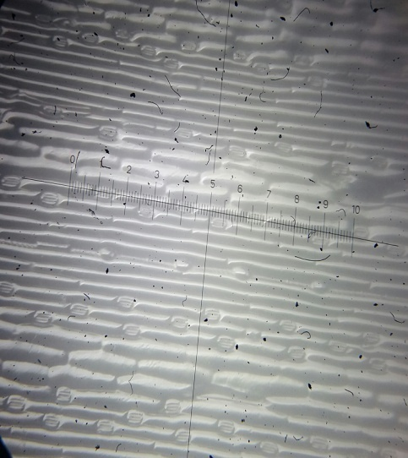 | 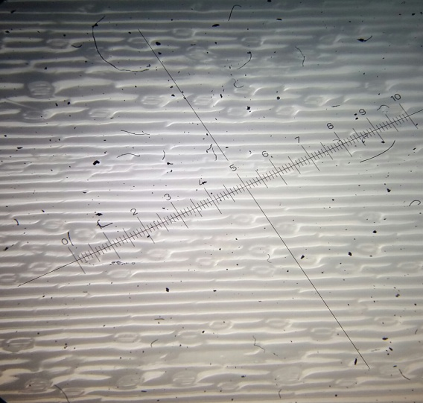
T₂C₃L | T₂C₂L | T₂C₁ L | T₂C₀L
Figure 3: Upper (adaxial) and Lower (abaxial) Avena sativa leaves surfaces stomata 100X (T₂C₀ U&L) stomata in Icarda tall plants and no irrigation water with salinity,(T₂C₁ U& L) stomata in Possum plants and irrigation water with salinity 0.5%, (T₂C₂U& L) stomata in Possum plants and irrigation water with salinity1%, (T₂C₃ U& L) stomata in Possum plants and irrigation water with salinity 2% .

Conclusions
From the results of this work it can be concluded that irrigation water with salinity affected significantly on the vegetative growth characteristics as well as chemical plant characteristics, especially at the higher concentration 2% in the open field. Interaction between irrigation water with salinity and different species increased significantly most of the vegetative growth characteristics and most chemical plant characteristics, whereas the interaction between Icarda tall and 2% gave high value respectively.

References

- Abd EL-Azim, WM. and Ahmed, STh, “Effect of salinity and cutting date on growth and chemical constituents of Achillea fragratissima Forssk, under Ras Sudr conditions”. Res. J. Agr. Biol. Sci., vol. 5(6), 1121-9. (2009).
- Abd El-Wahab, MA, “The efficiency of using saline and fresh water irrigation as alternating methods of irrigation on the productivity of Foeniculum vulgare Mill subsp. vulgare var. vulgare under North Sinai conditions”. Res. J. Agr.Biol. Sci., 2(6):571-7. (2006).
- Al-Sahaf, F. H., “Applied Plant Nutrition”. Ministry of Higher Education and Scientific Research, University of Baghdad. Al-Hikma House. Iraq. (In Arabic). (1989).
- Amira, M.S.and Abdul, Q., “Effect of salt stress on plant growth and metabolism of bean plant Vicia faba”. Journal of the Saudi society of agricultural science, 10, 7-15. (2011).
- Ashraf, M. and Orooj, A., “Salt stress effects on growth, ion accumulation and seed oil concentration in an arid zone traditional medicinal plant ajwain”. J Arid Environ, 64(2):209-20. (2006).
- Baghalian, K.; Haghiry, A.; Naghavi, Mr., and Mohammadi, A., “Effect of saline irrigation water on agronomical and phytochemical characters of chamomile (Matricaria recutita L.)”. Scientia Hort., 1(16): 437-41. (2008).
- Ben Saad, B. N. R., ; Ben Slima, A.; Khemakhem, B; Fendri, I.and Abdelkafi, S., “Effect of Salt Stress on Stress-associated Genes and Growth of Avena Sativa L’’. ESCO Journal of Science and Technology, Vol.10 (18), pp 73-80. (2014).
- Brindzova, L.; Čertik, M.; Rapta, P.; Zalibera, M.; mikulajova, A. and Takacsova.M., “Antioxidant activity, β-glucan and lipid contents of oat varieties’’, Czech Journal of Food Sciences, vol. 26, pp. 163-173. (2008).
- Chatuevedi, N; Yadav, S. and Shukla, K., “Diversified therapeutic potential of Avena sativa’’. Asian J. Plant Sci. Res.,1 (3):103-114. (2011).
- Chauhan, An.; Nidhi. R.; Deepak. K.; Ashok. K, and Chaudhry. A.K. “Effect of different of salt concentration on seed germination and seedling growth of different varieties of Oat (Avena sativa L.)”. International Journal of Information Research and Review Vol. 03, Issue, 07, pp. 2627-2632. (2016).
- Dhanapackiam, S. and Muhammad Ilyas. M.H.(2010). Leaf area and ion contents of Sesbania grandiflora under NaCl and Na2SO4 salinity. Indian J.Sci.Technol. Vol. 3 ,No. 5, ISSN: 0974- 6846, http://www.indjst.org
- Grattan, SR. and Grieves, CM, “Salinity-mineral nutrient relations in horticultural crops”. Scientia Hort., 78: 127-57. (1999).
- Hirich, A.; Halima El. O.; Sven, E. ; Nicola, L.; Atef, H.; Ragab, R.; Ahmed, J. and Redouane, Ch., “Chickpea (Cicer arietinum L.) physiological, chemical and growth responses to irrigation with saline water”. Australian journal of crop science (AJCS).,vol. 8(5):646-654.(2014).
- Iqbal, R.M. “Leaf area and Ion contents of wheat growth under NaCl and Na2SO4 salinity”. Pak.J . Biol.Sci, 6(17), 1512-1514. (2003). http:// www.pjbs.org.
- Jouyban, Z., 2012. The Effects of Salt stress on plant growth. Tech J Engin & App Sci., 2 (1): 7-10., www.tjeas.com.
- Khan, Ma. and Duke, NC., “Halophytes- A resource for the future”. Wetland Ecology and Management, 6:455-456. (2001).
- Kumar, A.; Agarwal, S. and Singh, A., “Salinity effects the germination and seedling growth in some cultivars of oat (Avena sativa L.)’’. Indian J. Adv. Plant Res. (IJAPR), Vol.1(2), pp 1-10, (2014).www.ijapronline.com
- Landizinsky, G., “Studies in Oat evolution a mains life with Avena sativa’’. Springer briefs in Agriculture. Vol 10(17), pp 87, http://www.springer.com. (2012).
- Lindlöf, B. M.; A.; Zakhrabekova, S.; Gharti-Chhetri, G.; Olsson, B. and Olsson, O., “Generation and analysis of 9792 EST sequences from cold acclimated oat, Avena Sativa’’, BMC Plant Biology, vol. 5, pp. 18. (2005).
- Rai, P. and Mishra, R. M., “Effect of urban air pollution on epidermal traits of road side tree species, Pongamia pinnata (L.)”. J. Environ. Sci., Toxicology & Food Techn., 2(6): 04 – 07. (2013).
- Reza A. H., “Design of Experiments for Agriculture and the Natural Sciences”. Chapman & Hall ICRC. New York. pp 437. (2006).
- Saida, Ch.; Belgat, H. and Baka, M., “Interactive effects of salinity and potassium on physio-morphological traits of tomato (Lycopersicon esculentum Mill; var: heintz)”. Agric. Biol. J. N. Am., 5(3):135-143, (2014).http://www.scihub.org.
- Tabatabaie, S. J. and Nazari, J., “Influence of nutrient concentration and NaCl salinity on growth, photosynthesis and essential oil content of peppermint and lemon verbena”. Turk J Agric., 31: 245-53.(2007).
- Tang,Y.; Huang, J. and Wang, R., “Change law of hyper spectral data in related with chlorophyll and carotenoid in rice at different developmental stages”. Rice science, vol 11(5-6): 274-282. (2004).
- Tester, M. and Davenport, R., “Na+ tolerant and Na+ transport in higher plants’’. Annals of Botany, 91: 503-527. (2003).
- Thomas, S. C. and Winner, W. E.. “Leaf area index of an old-growth Douglas-fir forest estimated from direct structural measurements in the canopy”. Canada J. For. Res. Vol. 30. (2000)
- Zan, W.; Yang, Xi; Wang Xue, Min. and Gao Hong, Wen., “Growth and physiological response of tall oat grass to salinity stress”. African Journal of Biotechnology, Vol. 10(37), pp. 7183-7190. (2011).
- Zhifang, G. and Loescher, WH., “Expression of a celery mannose 6-phosphate reductase in Arabidopsis thaliana enhances salt tolerance and induces biosynthesis of both mannitol and a glucosyl-mannitol dimmer’’. Plant Cell Environ, 26: 275–283. (2003).

